540-891-7800

RETURN TO KBI MUSIC SHOPPE

Date Returned to the Teacher _____________________

Home phone _____________________________________

Parent Name _____________________________________

Account Number __________________________________

School ____________________________________________

Student Name _____________________________________

Step 1: Fill out this paper completely and Step 2: Give the instrument directly to your
place it in the instrument case as shown below. band director at school for us to pick up.

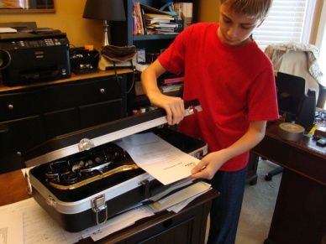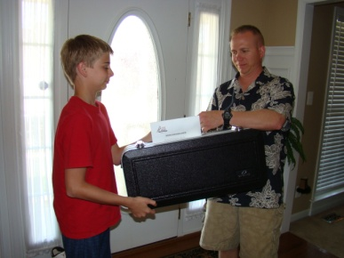

For instruments with fabric/canvas cases, please attach this paper to one of the
handles and staple it as shown below. Next give it directly to your band director for us to pick up.

